
Company
Logotype

Cone Beam Computed Tomography- Report



Porur Dental X-rays & CBCT

Patient Name : Mr. Jayaprakash | Date of Report : 15.06.2024
Age/ Gender : 29 years/ Male | Region of Interest : CBCT Sectional Maxilla
Referring doctor: Dr. Vigneshwaran | Indication : Implant assessment
Clinical Notes: Nil
PATIENT INFORMATION

CBCT- Sectional Maxilla provided
CBCT – IMAGE DETAILS

RADIOGRAPHIC INTERPRETATION

- In 17, 18 complete absence of crown and root structure evident.
- The alveolar bone in relation to 17, 18 appears to be degraded leading to reduced alveolar bone height and width.
- The tooth 16 is present with bone loss extending upto and beyond its apical third.

IMPLANT ASSESSMENT

 | 17 region
Available with of Alveolar ridge (in mm) | 3.14
Distance between the alveolar ridge and floor of the maxillary sinus (in mm) | 1.15

RADIOGRAPHIC IMPRESSION

- Implant assessment done in relation to 17.
- Chronic periodontitis: 16

Kindly correlate with clinical findings


IMAGES FOR REFERENCE

RECONSTRUCTED PANORAMIC VIEW
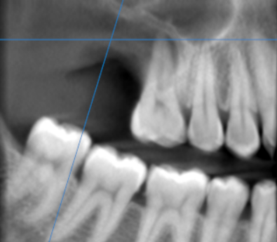

3-DIMENSIONAL VIEW

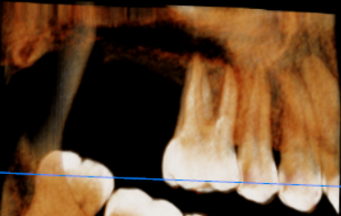

CROSS SECTIONAL VIEW

17 region | 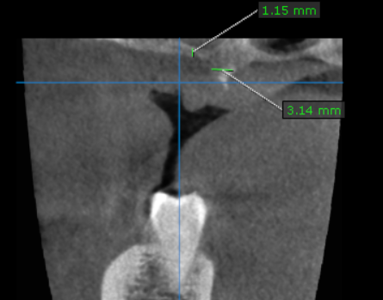

**** End of report ****

